VISA – FREE TRAVEL AND THE PROCEDURE FOR OBTAINING VISA TO ENTER THE REPUBLIC OF BELARUS

According to the Presidential Decree “On establishment of visa-free entry and exit of foreign nationals”, foreign citizens of 80 countries* can enter Belarus for up to 5 days** and exit from the territory of Belarus only through the State border checkpoint of the Republic of Belarus “Minsk National Airport”.
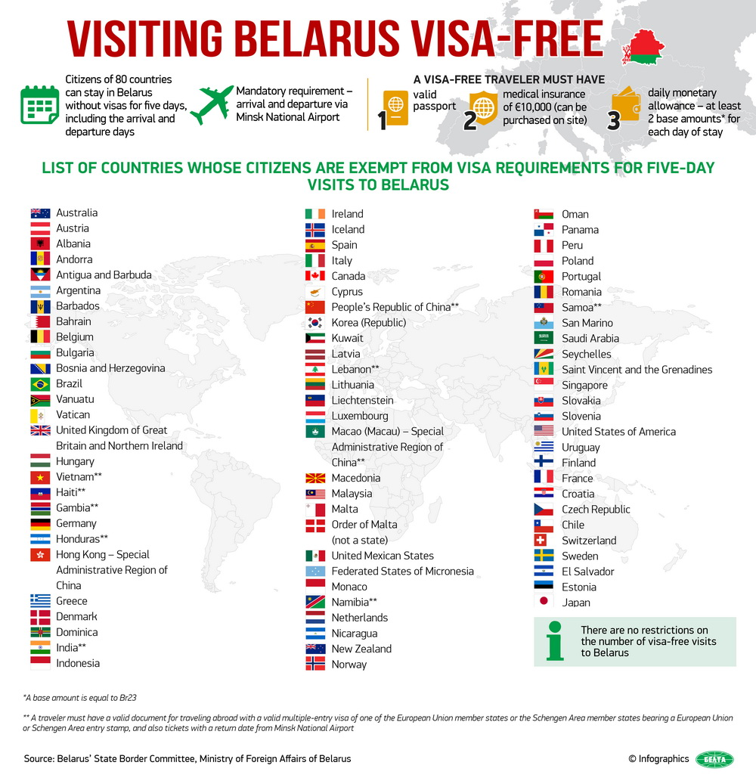

For more detailed information on Visa – free travel visit:
http://mfa.gov.by/en/visa/visafreetravel/c4bbfb78b29bccdc.html

The given order of visa-free movement through the airport does not extend to persons coming to Belarus by plane from the Russian Federation, as well as to those who intend to fly to the airports of the Russian Federation (such flights are considered as internal ones and do not have border control).

The Decree also does not apply to foreigners paying official visits. Diplomatic, official, special and other passports equal to them are not covered by the above Decree.

To enter the Republic of Belarus in the visa-free regime via the checkpoint “Minsk National Airport”, foreign nationals must have the following documents:

- a valid passport or another substituting document for traveling abroad;
- financial means: at least 25 Euro (or equal amount in dollars or Belarusian rubles) for each day of stay;
- medical insurance with coverage for at least 10,000 Euros that covers the territory of Belarus.

For more detailed information on visa-free travel via the checkpoint “Minsk National Airport” visit: http://mfa.gov.by/en/visa/visafreetravel/e0ced19bb1f9bf2c.html
For citizens of Vietnam, Haiti, Gambia, Honduras, India, China, Lebanon, Namibia, Samoa a valid multiple visa of the EU member states or Schengen zone with a mark in passport on crossing the border of these states and tickets with confirmation of departure from “Minsk National Airport” within 5 days from the date of entry is a compulsory additional requirement.

Visa-free regime is also provided for the citizens of Armenia, Azerbaijan, Cuba (for a term not exceeding 30 days), Georgia, Kazakhstan, Kyrgyzstan, Macedonia (provided that there is a private invitation or tourist voucher), Moldova, Mongolia (provided that there is a private invitation or tourist document), Montenegro (for a term not exceeding 30 days provided that there is a private invitation or tourist voucher), Qatar (for a term not exceeding 30 days), Russia, Serbia (for a term not exceeding 30 days), Tajikistan, Ukraine, Uzbekistan, Venezuela (for a term not exceeding 90 days).

For other citizens (not included in the visa-free travel) the procedure to obtain the entry visa is the following:
To obtain an entry visa, a foreign citizen should submit the following documents to a visa issuing authority - The Consular Department of the Embassy of the Republiс of Belarus.
1) one copy of a duly completed visa application form;
2) one photograph;
3) a foreign travel document;
4) visa support documents (our agency prepares these documents);
5) medical insurance policy;
6) visa fee.

PARTICULARS OF ISSUANCE OF ENTRY VISAS AT THE «NATIONAL MINSK AIRPORT » (NOT ANY OHER AIRPORTS!!!)

At the National Airport «Minsk» the entry visa requests are processed by the Division for the Admission of Foreigners of the Consular Department of the Ministry of Foreign Affairs (DAF).

Visa support documents are submitted to the DAF by our agency not later than 2 business days before expected date of arrival.

To obtain an entry visa at the airport (ONLY IN MINSK AIRPORT), a foreign citizen should submit the following documents to a visa issuing authority:

1) one copy of a duly completed visa application form;
2) one photograph;
3) a foreign travel document;
4) copy of visa support documents (our agency prepares these documents and submits to DAF);
5) medical insurance policy (an applicant may have his own medical insurance VALID IN ALL COUNTRIES, otherwise it is possible to obtain Belarusian medical insurance at the airport);
6) visa fee

For more detailed information on obtaining Belarusian visas at the «National Airport Minsk» and the rates of consular fees visit: http://mfa.gov.by/en/visa/info/d72e8d0162feaad1.html. Visa fee is paid by the foreigner at the DAF visa desk upon arrival in cash.

